HIMSS 2017 第四天

1．Imaging Informatics: From Ideas to Action at SIIM

1.1 企业级的图像处理恰逢其时

在医疗领域，影像数据已经得到了广泛的应用，几乎每个临床科室都可能涉及到影像数据。需要处理的影像数据的量也在急剧增加，因此企业级图像处理也得到了空前的发展。

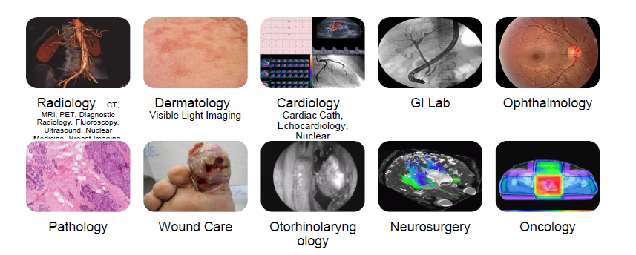

HIMSS和SIIM的合作将进一步推动企业级图像处理在医疗领域的应用。两个组织合作推出了一系列白皮书。

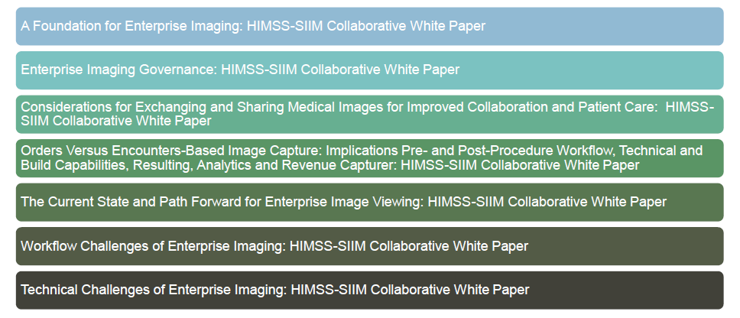

1.2 Value-based Imaging

医疗图像相关的工作流程：



价值的定义：



如何体现价值：

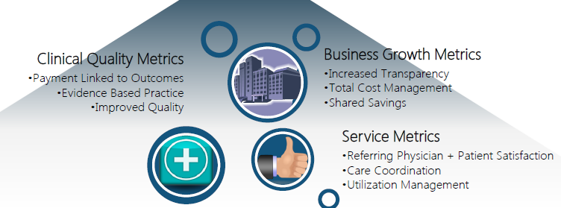

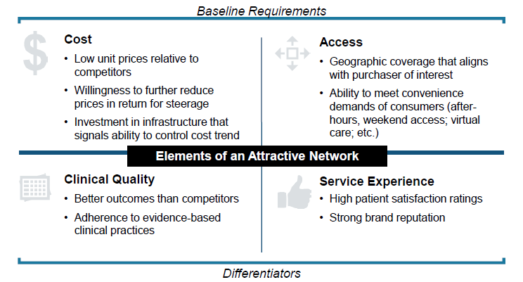

1.3 将DICOM标准移到 Web上

移到Web上之后，数据的结构和DICOM一致：

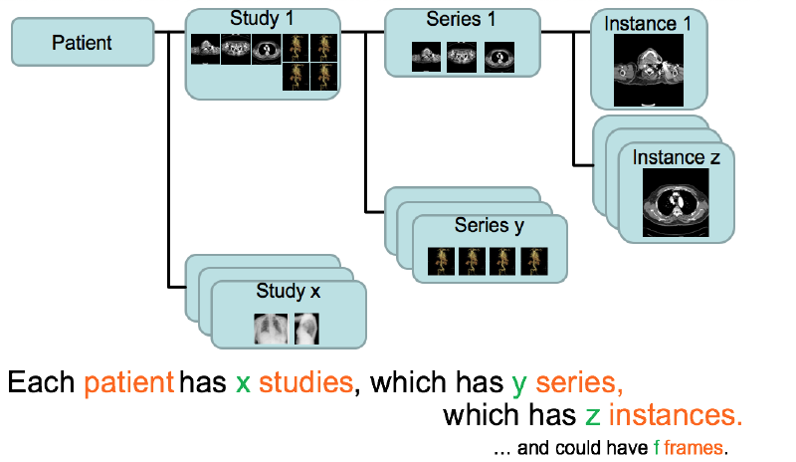

与现有DICOM协议兼容：

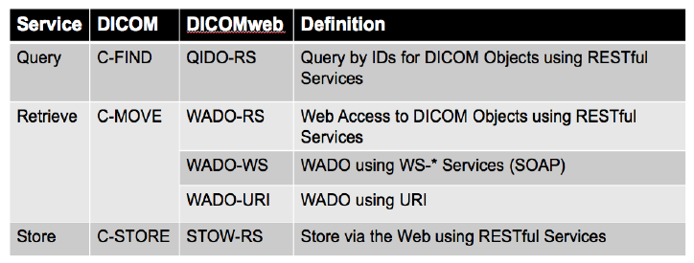

基于http传输数据：

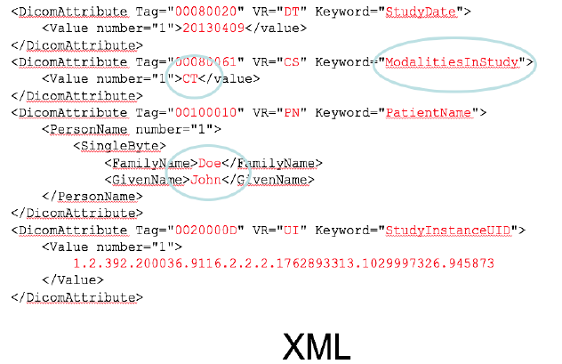

1.4 机器学习技术正在起飞

机器学习已在一些领域取得了进展：

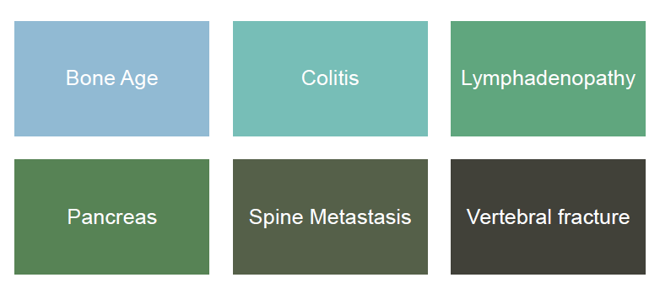

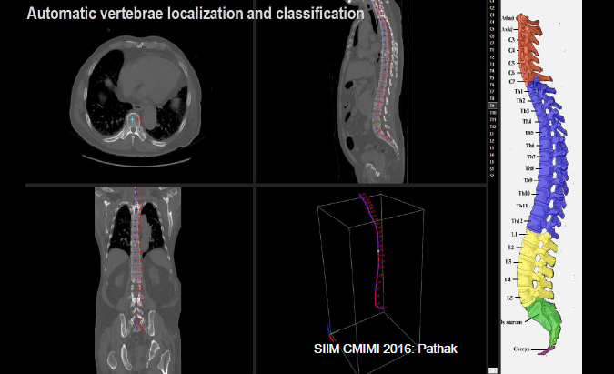

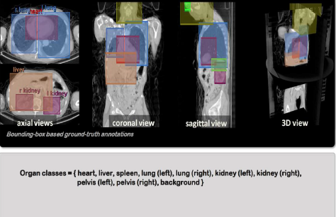

Github上已有很多相关项目和代码贡献者：

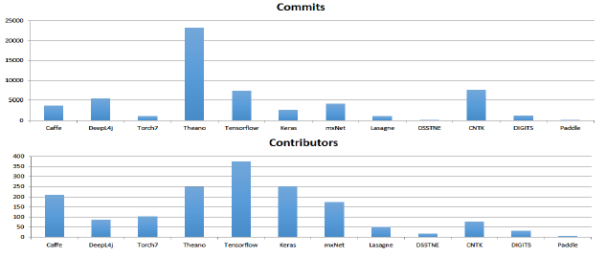

2．Enabling Advanced EHR Analytics with Clinical Terminology

临床数据（主要指文本数据）的分析就是用临床上有特定含义的模式或者结构来对临床数据进行解释和通信。尽可能从临床数据中得到有价值的信息，以便使患者、医生以及相关研究者收益，也使公众受益。

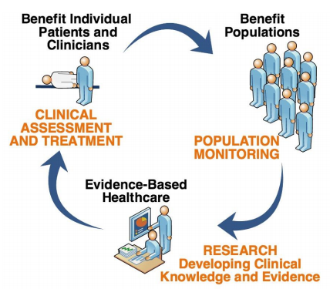

语言的复杂性，以及表达的含混不清都制约着临床数据分析，有的时候一个词表达着不同的含义，有的时候不同的词又表达了相同的含义。因此，为了克服这些临床数据分析上的障碍，急需要定义一套含义清晰表达一致的临床术语规范来帮助临床数据分析，SNOMED CT应运而生。

**Note(from wiki):** SNOMED CT [a] or SNOMED Clinical Terms is a systematically organized computer processable collection of medical terms providing codes, terms, synonyms and definitions used in clinical documentation and reporting. SNOMED CT is considered to be the most comprehensive, multilingual clinical healthcare terminology in the world.[2][non-primary source needed] The primary purpose of SNOMED CT is to encode the meanings that are used in health information and to support the effective clinical recording of data with the aim of improving patient care. SNOMED CT provides the core general terminology for electronic health records. SNOMED CT comprehensive coverage includes: clinical findings, symptoms, diagnoses, procedures, body structures, organisms and other etiologies, substances, pharmaceuticals, devices and specimens.

SNOMED CT is maintained and distributed by SNOMED International, an international non-profit standards development organization, located in London, UK. SNOMED International is the trading name of the International Health Terminology Standards Development Organisation (IHTSDO), established in 2007.

SNOMED CT provides for consistent information interchange and is fundamental to an interoperable electronic health record. It provides a consistent means to index, store, retrieve, and aggregate clinical data across specialties and sites of care. It also helps in organizing the content of electronic health records systems by reducing the variability in the way data are captured, encoded and used for clinical care of patients and research.[3] SNOMED CT can be used to directly record clinical details of individuals in electronic patient records. It also provides the user with a number of linkages to clinical care pathways, shared care plans and other knowledge resources, in order to facilitate informed decision-making, and to support long-term patient care. The availability of free automatic coding tools and services, which can return a ranked list of SNOMED CT descriptors to encode any clinical report, could help healthcare professionals to navigate the terminology.

SNOMED CT is a terminology that can cross-map to other international standards and classifications.[4] Specific language editions are available which augment the international edition and can contain language translations, as well as additional national terms. For example, SNOMED CT-AU, released in December 2009 in Australia, is based on the international version of SNOMED CT, but encompasses words and ideas that are clinically and technically unique to Australia.[5]

在用SNOMED CT这套术语规范分析临床数据之前，先要对临床数据进行预处理，流程如下：

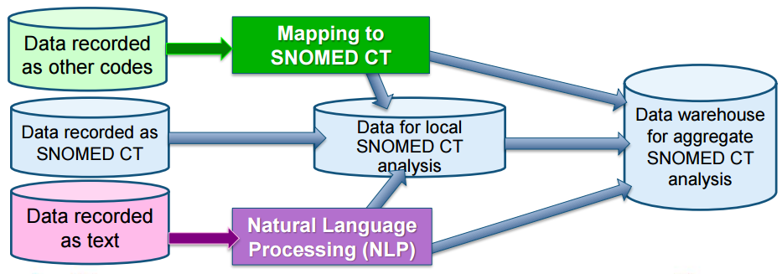

预处理后数据可以通过如下方法进一步处理：

